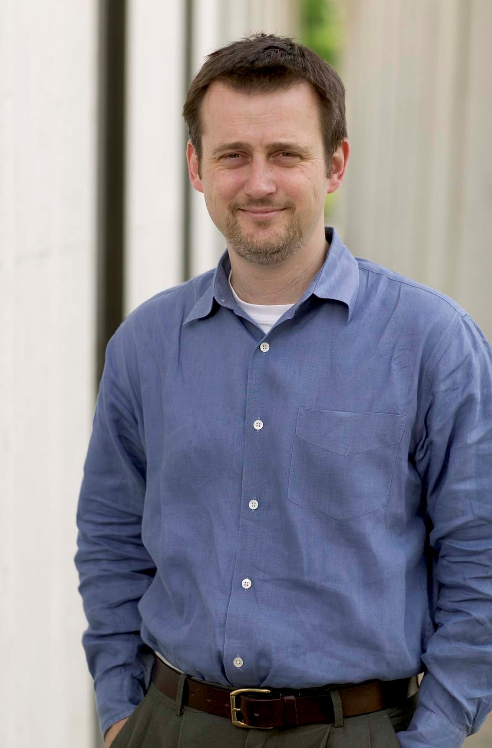
Nolan McCarty
Professor of Politics and Public Affairs
Woodrow Wilson School
Princeton University

