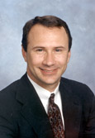 Andrew J. Rettenmaier

