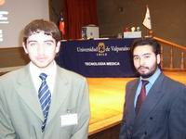 Guillermo Tolosa (gentleman to the right)

