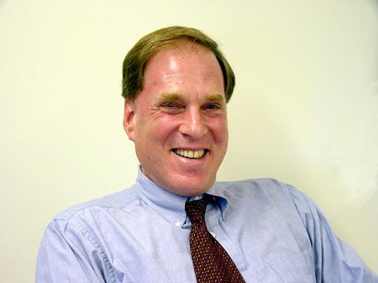 | Marc Trachtenberg  Professor  U.C. Berkeley, 1974  (310) 267-1904
Marc Trachtenberg studies national security strategy, diplomaticCold War
Marc Trachtenberg

