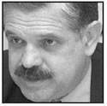

Ricardo Lopez Murphy

