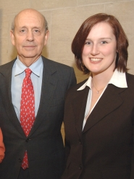Tracy Flint
pictured here with Supreme Court Justice Stephen Breyer. Tracy will begin working for Breyer as a law clerk in July 2006

