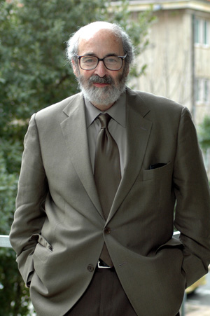Alan Charles Kors

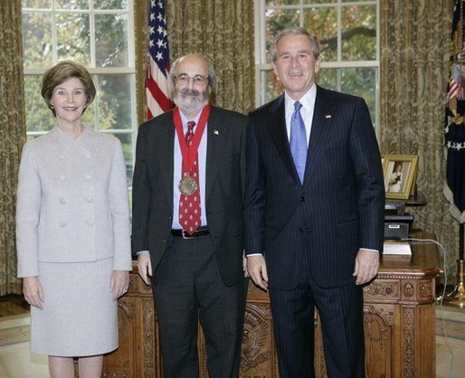 President George W. Bush and Laura Bush stand with 2005 National Humanities Medal recipient Alan Kors, historian, Thursday, November 10, 2005 in the Oval Office at the White House. White House photo by Eric Draper

