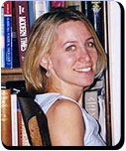
Lecturer
Linda Rabieh - Political Theory
PhD, University of Toronto, 2001
Linda Rabieh teaches political philosophy and supervises students who pursue political science internships. Her research interests include classical political philosophy, the nature and role of gender in Greek classical thought, and the philosophical questions surrounding war

