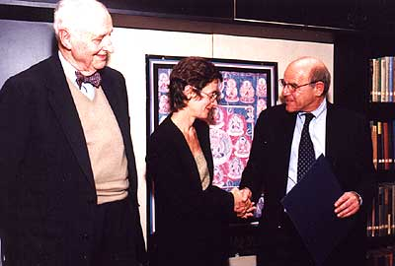
Kathy Eden, center, accepts the 2001 Core Award from David H. Cohen, right, vice president of arts and sciences, while Wm. Theodore de Bary, John Mitchell Mason Professor Emeritus, looks on.

