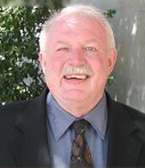 | THOMAS BORCHERDING

