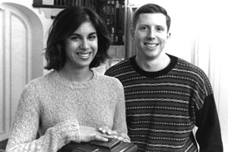

Sara Karimbhoy (left)

