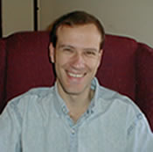

Severin Valentinov Kitanov

