Albert Keith Whitaker

Family Wealth Counseling

Philanthropic Advising
Private Trusteeship
Telephone: 781.893.8040
Fax: 781.891.4088
800 South Street - Suite 195
Waltham, MA 02453
albert.whitaker@calibre.com
(781) 392-2803

Albert Keith Whitaker is Research Fellow at Boston College's Center on Wealth and Philanthropy and Director of Family Dynamics for Calibre Advisory Services, Wachovia's family office. He earned his BA in classics and philosophy and an MA in classics from Boston University, and his PhD in Social Thought from the University of Chicago. He also holds a certificate in National Security Studies from the University of Kiel, Germany, and the Certified Trust and Financial Advisor designation from the American Bankers Association.

Dr. Whitaker taught writing and philosophy for many years at Boston College and Boston University. In addition, he worked as an assistant to two Boston University Presidents, and currently serves as Director and President of the Morton Foundation, a private operating foundation devoted to education. He directs the Morton Seminar Program, which hosts seminars on moral education through biography at colleges and universities throughout the country.

Dr. Whitaker has written two books on Plato, and he has edited over twenty volumes of classical Greek, Latin, and German texts in translation. Currently he is writing, with Paul Schervish, Director of the Center on Wealth and Philanthropy, a book on philosophy, spirituality, and philanthropy.

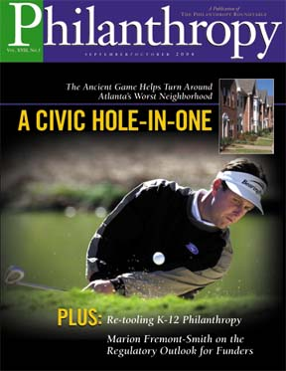

Selected Recent Publications

It is Better to Receive and to Give (Philanthropy Magazine, July/August 2006)
Political Wisdom: Review of Andrew Rich's Think Tanks (Philanthropy Magazine, May/June 2006)
Taking the Time to Teach: Raising Children Amid Affluence (Calibre Papers, 2006)
Not Only Ideas: Friendship and Conservative Philanthropy (National Review Online, March 9, 2006)
Leaving a Legacy of Care: Less to Heirs and More to Charity (Philanthropy Magazine, January/February 2006)
Primer on Investment Management for Private Foundations (Association of Small Foundations, 2006)
A Philanthropy of Friendship: Giving as a Yearning to Connect (More than Money Magazine, 2005)
Citizen Philanthropist: Review of David H. Smith's Good Intentions (Philanthropy Magazine, 2005)
I Give Only to My Friends (Dialogues on Civic Philanthropy, 2005)
Inside the Family Office: Review (Journal of Financial Planning, 2005)
Balancing Private Happiness with Public Goods: Review of Kelin Gersick's Generations of Giving and Roy Williams and Vic Preisser's Philanthropy, Heirs & Values (Philanthropy Magazine, 2005)
Philanthropy's Indispensable Ally: Financial Security (Philanthropy Magazine, 2005)
Charity and Prosperity: Review of Claire Gaudiani's The Greater Good (Philanthropy Magazine, 2005)
All in the Family: Review of Jay Hughes' Family Wealth (Philanthropy Magazine, 2004)
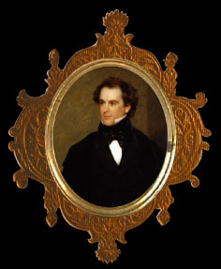
Great American Hustle: Review of Walter McDougall's Freedom Just Around the Corner (Books and Culture, 2004)
Neoconservative Nathaniel: Bioethics and the Birthmark (Hawthorne in Salem, 2004)
California Dreamin' in the Postmodern Academy (Journal of Education, 2004)
Critical Thinking in the Tower Ivory (Academic Questions, 2003)

Teaching Lincoln (Partisan Review, 2003)
Course Reasoning: The University of Chicago Dumps Western Civ (National Review Online, 2002)
Old-School Civics (National Review Online, 2002)
College Carnival: Campus Life (National Review Online, 2002)
Leon Kass: Soul Doctor (National Review Online, 2002)
Baleful Signs: Writing in the Academy (Academic Questions, 2002)

Philosophy Publications

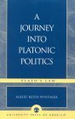
A Journey into Platonic Politics: Plato's Laws (University Press of America, 2004); published reviews here, here, and here.
The Bible and Philosophy: Review of Leon Kass and Thomas Pangle on Genesis (Claremont Review of Books, 2003); published response and reply
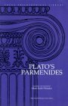
Review of Pierre Hadot's What is Ancient Philosophy? (Classical Bulletin, 2003)
Review of Robert Lamberton's Plutarch (Classical Bulletin, 2002)
Plato's Parmenides (Focus Philosophical Library, 1996); published review

Other Published Squibs

Letter on Science Education (University of Chicago Magazine, 2004)
Interview on Publishing (Boston College, 2004)
A Declaration of Independence: Reaffirming the Autonomy of the Third Branch (lead researcher, Pioneer Institute, 2002)


Unpublished, but Not Unloved, Opuscula

Hotter than Ever: The Wicker Man at 30 (2003)
Analogies: the SAT and the Universe (2002)

