David Matkowsky is a founding member of Beat'achon. He was born in Albany, NY, and when he was ten years old his family moved to Skokie, Illinois. Within a year he tracked them down. Currently Dave is pursuing a Ph.D. in Politics at New York University, and working for the Shalem year program in Israel for high school graduates. Dave and has served as the group's director of Public Relations.

Jewish A Cappella
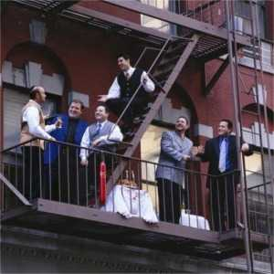
BEAT’ACHON is the world’s premier Jewish A Cappella singing group, bringing a fresh and exciting new sound to the Jewish music scene. Beat’achon’s unique blend is part “doo-wop,” part pop and rhythm & blues, celebrating traditional Jewish lyrics with a vibrant contemporary musical style. The six-man ensemble combines rich vocal harmonies and catchy rhythms in its repertoire of original compositions and arrangements, ranging from spirited upbeat tunes to soulful ballads.
what’s in a name…
The name Beat’achon is a transliteration of the Hebrew word for faith. An unusual English spelling was chosen to include the musical term “beat” within the larger word.
the rest is history…
Beat’achon was formed in 1991 by six boyhood friends who grew up singing and harmonizing together at the Shabbat table.

