John Hittinger is a professor of philosophy at Sacred Heart Major Seminary in Detroit and the author of Liberty, Wisdom, and Grace: Thomism and Democratic Political Theory (Lexington Press, 2003).

John Hittinger, Director
Department of Philosophy, Air Force Academy

Political Philosophy
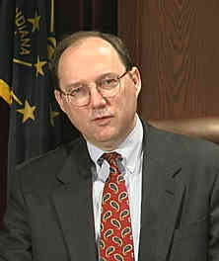
John Hittinger is a civilian professor of philosophy at the U.S. Air Force Academy. He was educated at the University of Notre Dame, the University of Dallas, and the Catholic University of America. He has published articles on such thinkers as Maritain, Simon, Locke, and Newman.

New Job as of Fall 2006
John Hittinger, Ph.D., is Vice-President and Provost of StUniversity of St. Thomas, Houston, TX
Dr. John P. Hittinger | Vice President | Academic Affairs | Mail: 60 | 525-6999
University of St. Thomas 3800 Montrose - Houston, Texas 77006 713.522.7911

