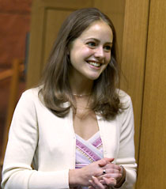

Jacqueline Volkman
Hometown: Wilmington, DE
Favorite Class: Econometrics
Previous Education: Bachelor of Science in Mathematics and Economics, Pennsylvania State University
Recent Work History: Investment banking summer analyst, Lehman Brothers
Place of Residence: West Philadelphia
Extracurricular Activities: Jogging and swimming
Favorite Restaurants: New Deck Tavern, White Dog Café, coffee shops
Hobbies: Art Museum, going to movies
Jacqueline M. Volkman
3015 SH-DH
jvolkman@wharton.upenn.edu
215-898-3589
Matriculation Year: 2002

