Jessica Dean  Halibut  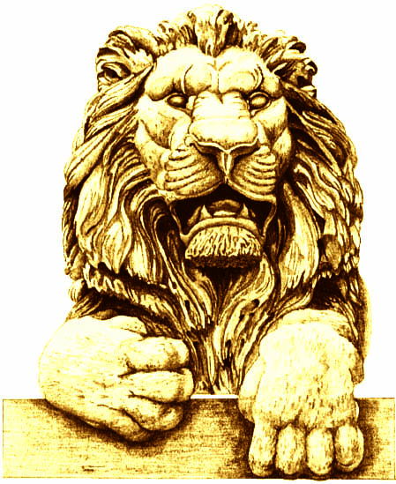 | Terry Considine  Halibut
Pat English  Halibut | Terri Famer  Filet – Medium well
Cynthia Friauf  Filet | Robby George  Filet
Rick Graber  Filet | Mike Grebe  Filet
Mike Hartmann  Filet | Diane Hendricks  Halibut
Mandy Hess  Filet | George Kelling  Filet
Dionne King  Filet - Well | Dennis Kuester  Filet
Mike Lempke  Filet – Medium well | Alicia Manning  Filet *
Cleta Mitchell  Filet | Art Pope  Filet
Jan Riordan  Filet | Dan Schmidt  Filet
Dianne Sehler  Halibut | Dave Uihlein  Filet
David George

Filet

